Lesson 2: Working with Data Sources and Data Preparation in Tableau
Name: Mohammed Aquib Shahazia

Step A: Connecting to Data Sources
Connected to the Orders.csv dataset to establish the structural foundation of the data model.
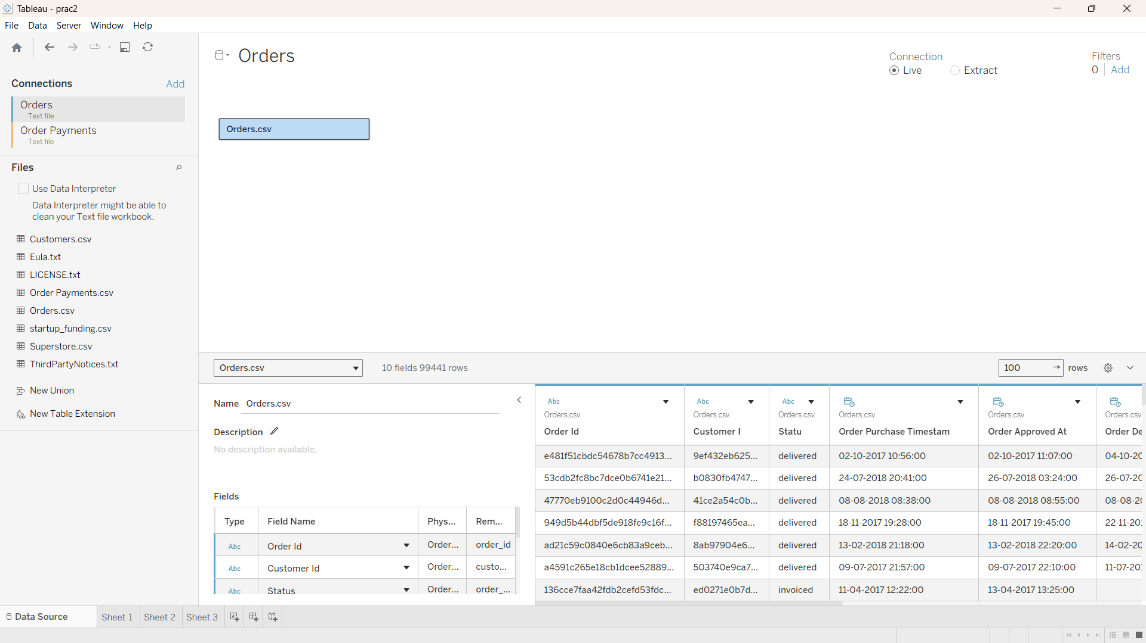

Step B: Creating Data Extracts vs. Live Connections
Switched the connection mode from Live to Extract and saved the local snapshot file as 'Ecommerce Extract' to optimize processing.
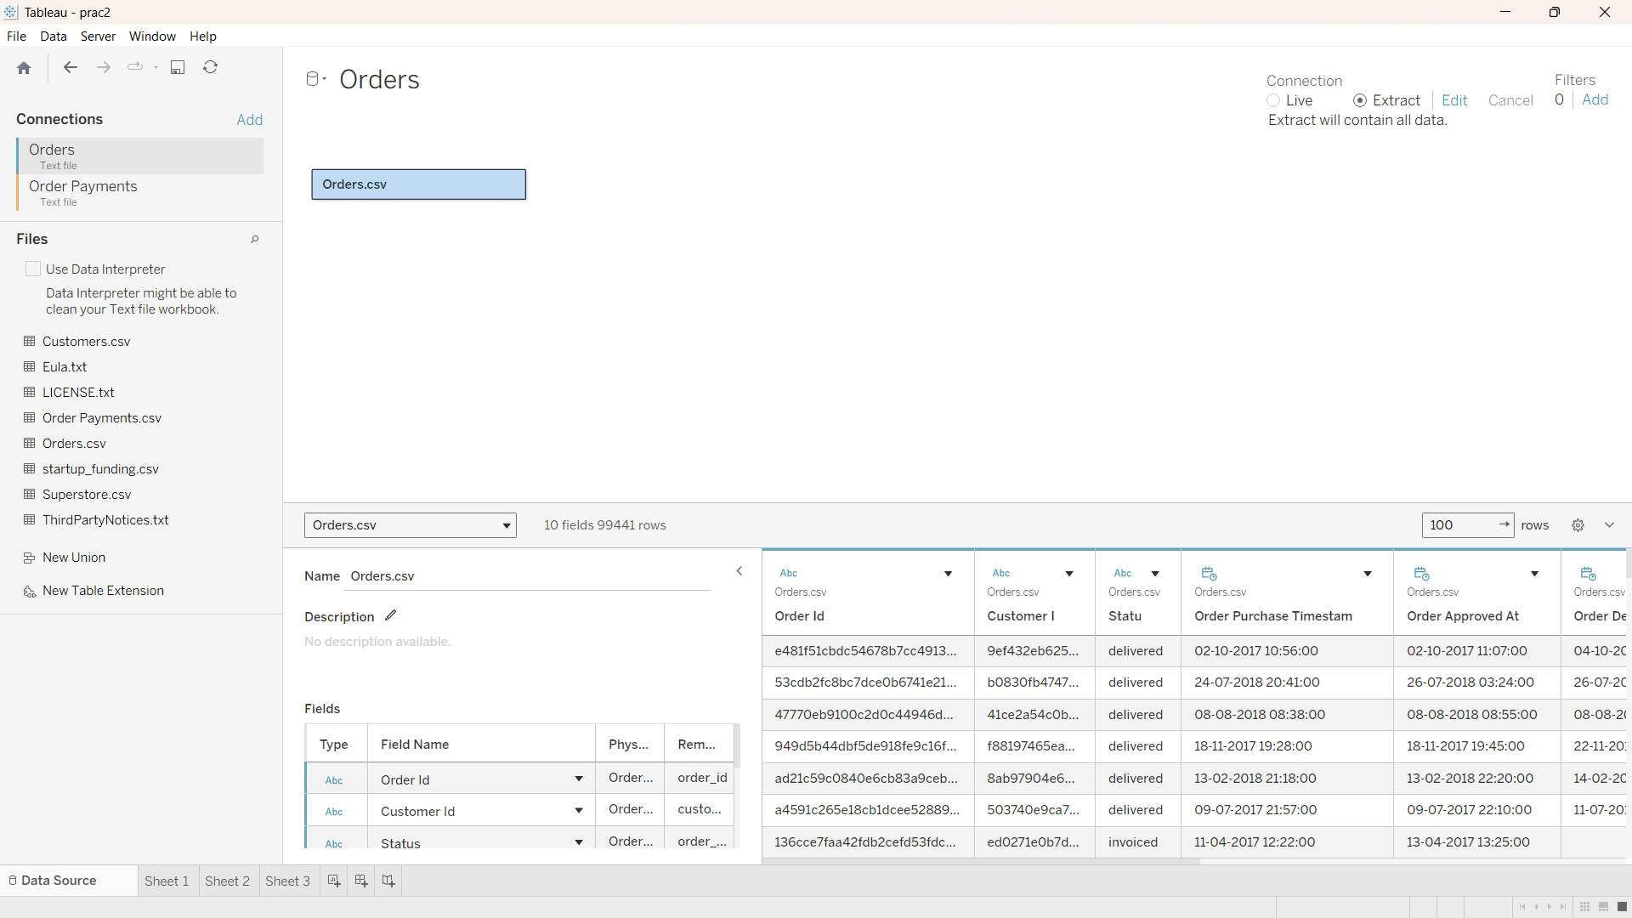

Step C: Managing Operational Metadata
Renamed the 'order_status' field to 'Status', hid unnecessary system tracking codes, and corrected the 'order_purchase_timestamp' data type to Date & Time.
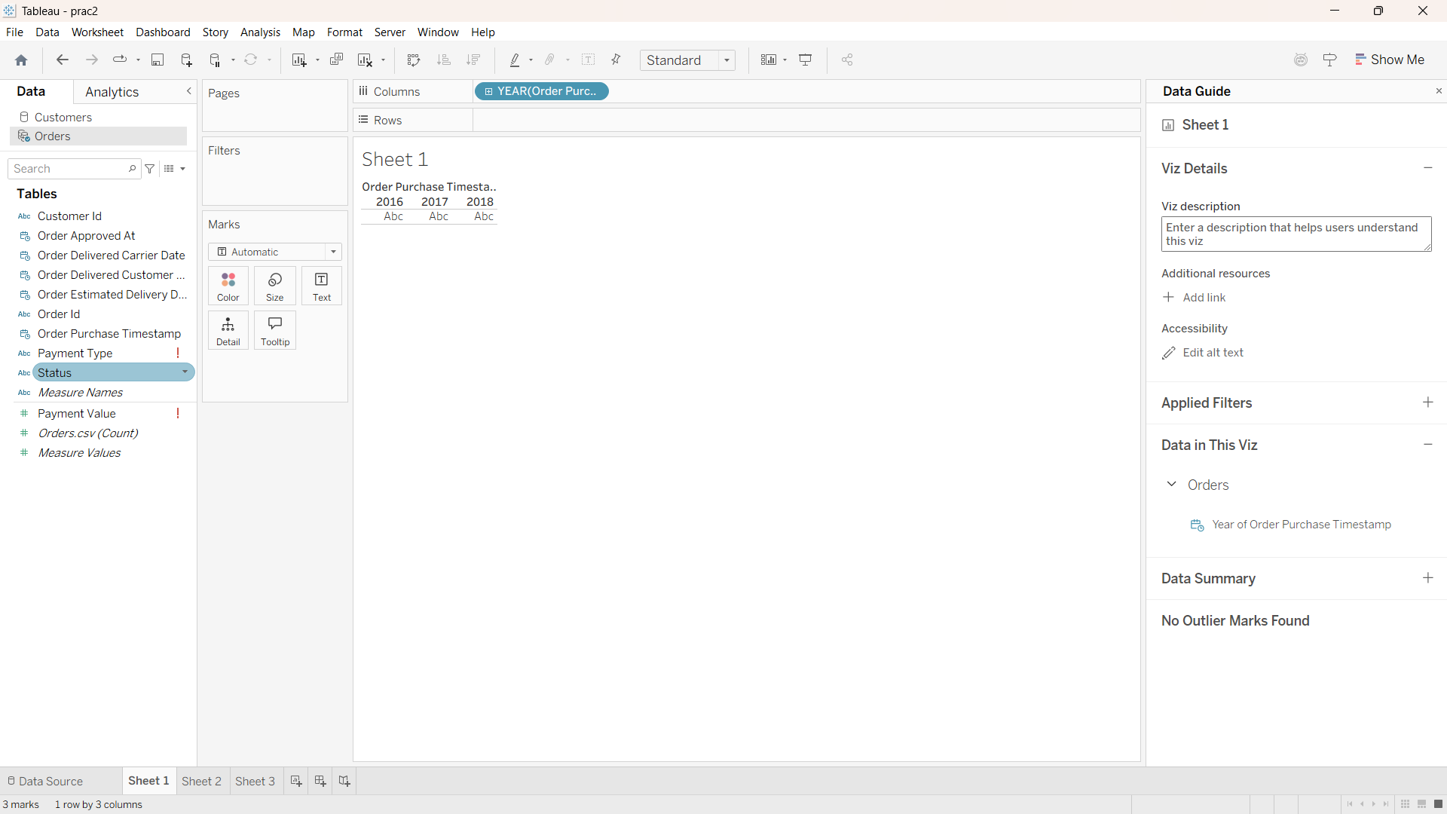

Step D: Performing Relational Joins
Executed a Left Join between Orders.csv and Order Payments.csv using 'order_id' as the matching data key to consolidate the data while preserving all order history logs.
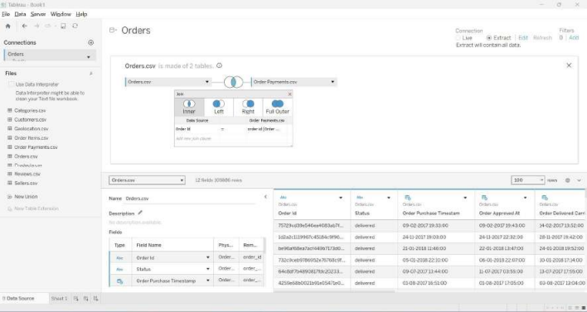

Step E: Applying Data Blending Between Independent Sources
Applied Data Blending to connect the independent Customers.csv dataset. Linked the primary and secondary sources using 'customer_id' and added 'customer_state' to the view.
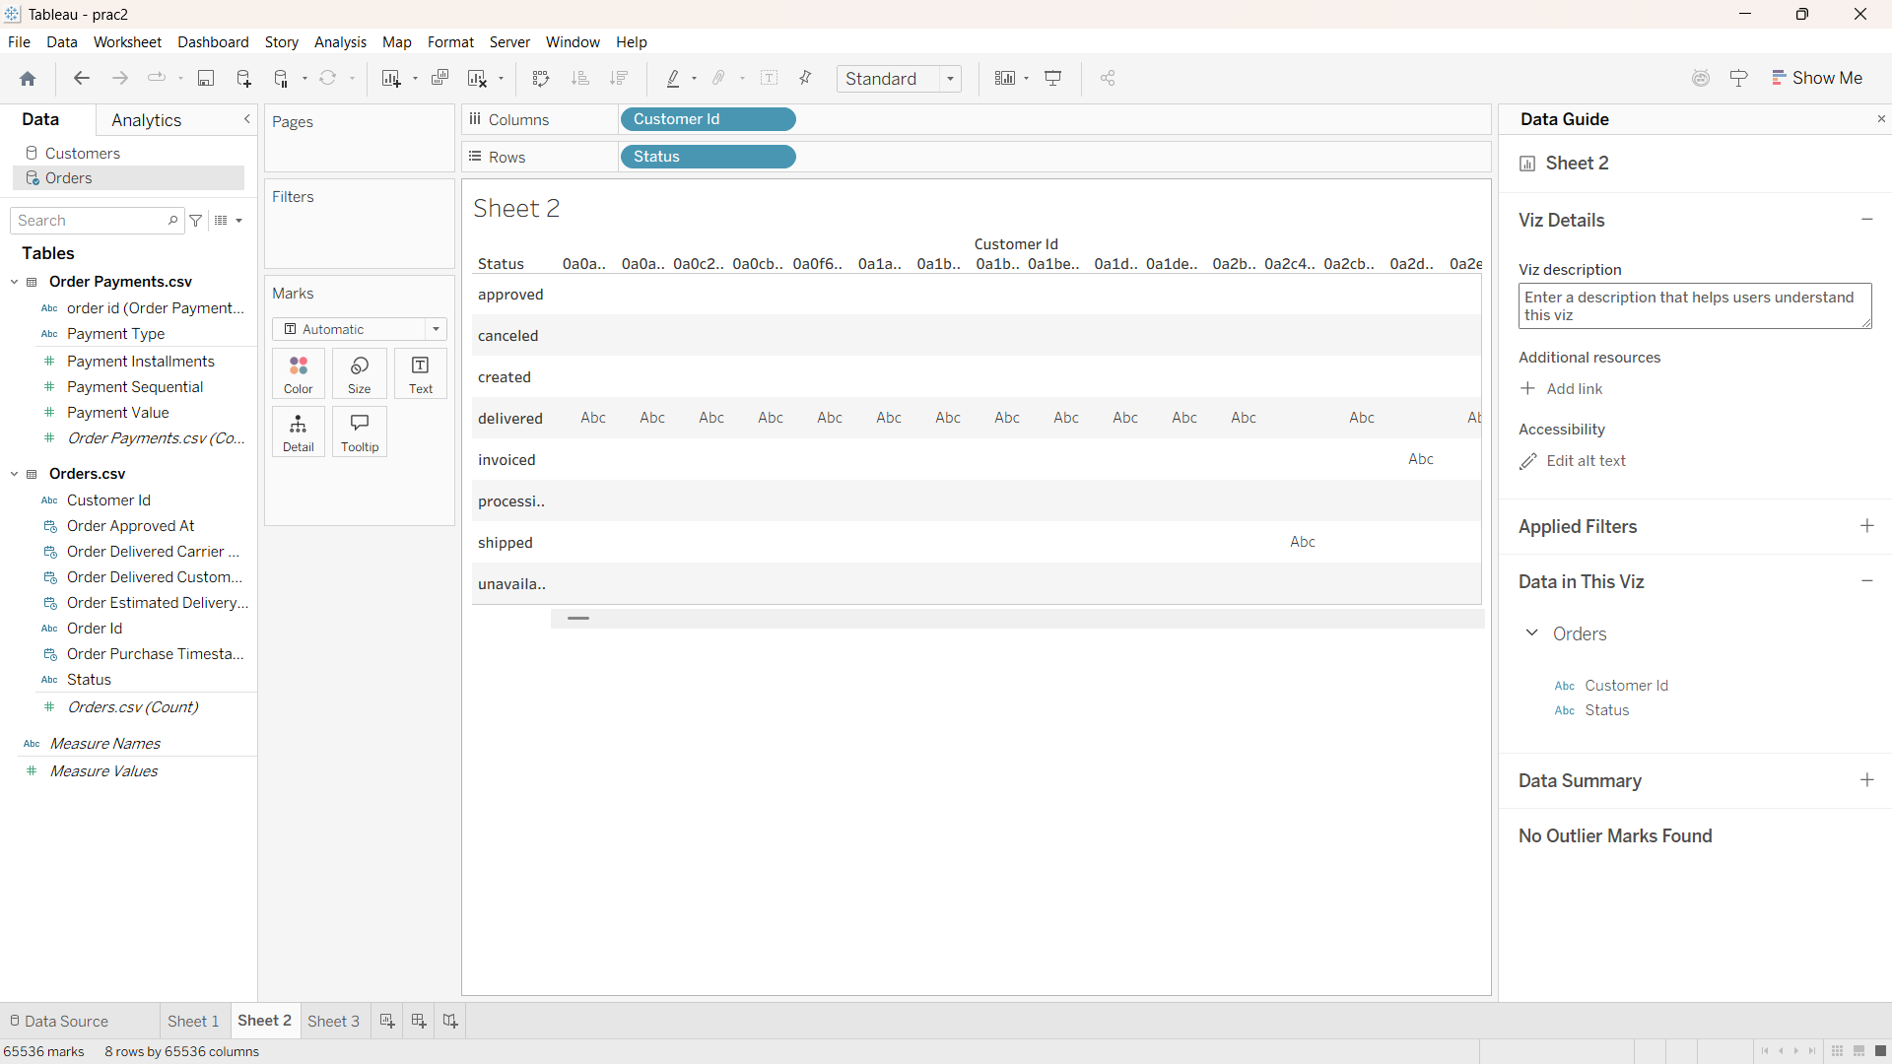

Step F: Implementing Multi-Tiered Filters
Applied Dimension Filters (isolating credit card and boleto payments), Measure Filters (filtering payment values to at least 50), and Date Filters (restricting the order_purchase_timestamp).
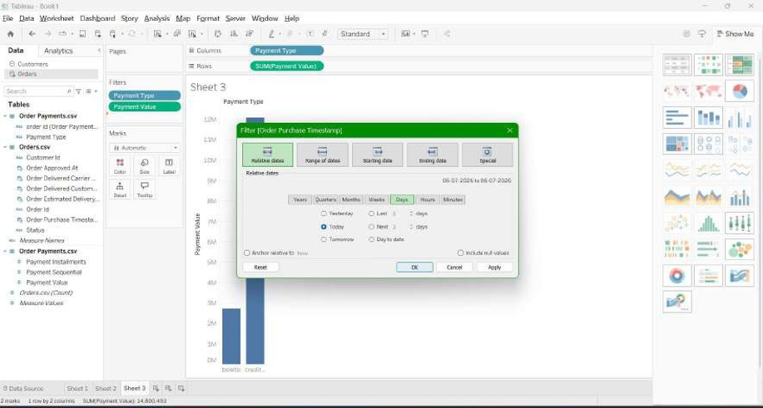

Step G: Optimizing Dashboard Performance
Added an Extract Filter to exclusively include 'delivered' statuses, purging canceled orders. Also applied a Context Filter to the worksheet to ensure primary filtering executes first, reducing temporary data table size.
